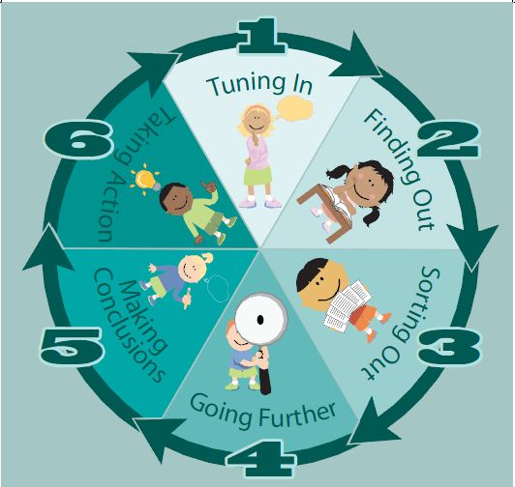
Kath Murdoch’s Inquiry Cycle

TUNING IN

What do I know about the topic?
How do I know about it?
What experience do I have with this topic?
What do I want to know?
What ideas am I interested in?
What am I wondering?
What are my questions?
What am I feeling?

FINDING OUT

Where might I go to find out more information?
What resources might I use?
What key words could I use in my searches?
Where can I find different points of view on this?
What can I do to learn more?
What are my questions?
How do I know if my resources are good?
What am I feeling at this phase?
Is there anything I can do about the way I feel to be successful?

SORTING OUT

How can I sort the information I have found?
What information helps answer my questions or the questions of others?
What keywords help me make sense of the information I found?
Do I need to find out more information?
How is it connected to what I know?
What are my questions now? How have they changed?
What changes do I need to make to my inquiry?
How are my ideas changing?
What am I feeling about my inquiry at this phase?
GOING FURTHER

What information do I wish to share?
Who will be my audience?
Are all my questions answered?
Have I considered the different points of
view on this topic?
Have I found enough information?
How can I plan to show the connections I
have made?
How do I want to show what I have learned?
What am I feeling about showing what I have learned?

MAKING CONCLUSIONS

What do I know and understand about the Philosophical Question?
Have I shared what I have learned with others effectively?
Did I answer all my questions?
What am I going to do with what I have learned?
What would I do differently?
What do I feel about the way I shared my learning?
How do I feel about what others thought?

TAKING ACTION

How can what I have learned help me in my life or help others?
How can I improve my learning?
How did I learn best?
How am I going to take action to improve my learning?
How am I going to use what I learned to make a difference?
How will my actions affect others?
What was the highlight of this inquiry?
How have my feelings changed throughout this inquiry process?
From what I have learned, what do I feel most passionate about?

